INITIAL ASSESSMENT FORM

Name: ______________________ BP: ______/______ HR: ______
Wt: __________ Ht: _________
Date: ___________ Temp: __________

Location of pain: Please shade your area of pain Please check what describes your pain:
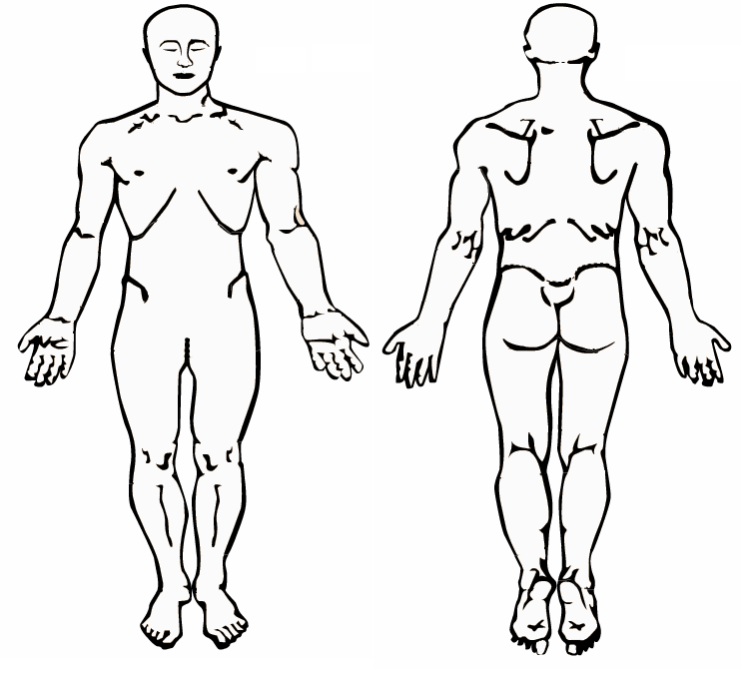
☐ aching ☐ throbbing ☐ dull ☐ sharp ☐ stabbing
☐ shooting ☐ burning ☐ other:________________________
Right
Left
Please check if you have associated symptoms:
☐ numbness ☐ tingling ☐ muscle spasm ☐ weakness
☐ bowel or bladder incontinence ☐ pins and needles

What worsens your pain? ☐ coughing ☐ straining ☐ standing
☐ bending ☐walking ☐ sitting ☐ driving ☐ touch
☐ cold ☐ Other: _______________________

What makes your pain better? ☐ rest ☐ cold ☐ warmth
☐sitting ☐ standing ☐ medication ☐ Other:___________________________

Indicate the one NUMBER between 0-10 that best describes your pain:
Left
Right

No pain moderate pain severe pain unbearable
0 1 2 3 4 5 6 7 8 9 10

_______ Pain at its worst ________ Pain at its least
_______ Average pain ________ Pain now

History of present illness: Is your injury ☐ work related or ☐ auto accident? Date of injury ________ State injury occurred ______
Describe the incident: __________________________________________________________________________________________
____________________________________________________________________________________________________________
____________________________________________________________________________________________________________

Review of systems

General
☐ fatigue
☐ fever
☐ weight loss/gain
Eyes
☐ vision loss

Head/Ears/Nose/Throat
☐ hearing loss
☐ nose bleed
☐ sore throat

Cardiovascular
☐ chest pain
☐ palpitations

Respiratory
☐ cough
☐ shortness of breath

Gastrointestinal
☐ vomiting blood

Genitourinary
☐ loss of bladder control
Musculoskeletal
☐ joint pain/swelling
☐ spasms
☐ weakness
Skin
☐ color changes

Neurological
☐ paralysis
☐ seizures

Psychiatric
☐ depressed mood
☐ hallucination
Endocrine
☐ elevated blood sugar

Hematology/Lymphatic
☐ bleeding
☐ bruising

Previous treatment

Did you have previous pain management? With who? __________________________ Treatments: _____________________________________

Did you have injections? ☐ No ☐ Yes, if so any relief? ___________

Did you have any alternative therapies: ☐ chiropractor ☐ acupuncture ☐ physical therapy ☐ Other__________________________
If so any relief? ___________

Relative surgical history
☐ Back surgery ☐ Neck surgery ☐ Spinal cord stimulator ☐ IT Pain pump ☐ Defibrillator/Pacemaker

☐ Other: _____________________________________________________________________________________________________________________________

Current medications ____________________________________________________________________________________________________
____________________________________________________________________________

Blood thinners ☐Aspirin ☐Plavix ☐Warfarin ☐Lovenox ☐Pradaxa ☐Ticlid ☐Pletal

Previous pain medication
☐ Vicodin ☐ Percocet ☐ Dilaudid ☐ Oxycontin ☐ Oxycodone ☐ Fentanyl

☐ Suboxone ☐ Methadone ☐ MS Contin ☐ Other: ______________________________________

Medication allergies
☐ No known drug allergies ☐ Betadine/Iodine ☐ Contrast dye ☐ Latex ☐ Medication allergies: ___________________________________________

Past medical history (please check all that apply)
☐ AIDS/HIV ☐ Diabetes ☐ Cancer: _______________ ☐ Hepatitis B / C ☐ Heart Disease
☐ Bleeding Disorder ☐ Stroke/Mini-Stroke ☐ Multiple Sclerosis ☐ Liver Disease ☐ Kidney Disease
☐ COPD ☐ Stomach/Intestinal Ulcers ☐ High Blood Pressure ☐ Obstructive Sleep Apnea ☐ Other: ______________________
☐ Alcoholism ☐ Previous Addiction ☐ Drug Abuse ☐ Bipolar Disorder ☐ Generalized Anxiety Disorder

Family history
Is your Mother living? ☐Yes ☐ No If no, age deceased____________cause of death________________________________________________
Is your Father living? ☐Yes ☐ No If no, age deceased____________cause of death________________________________________________

Family history related conditions
☐ arthritis ☐ cancer ☐ ankloysis spondylosis ☐ other_________________________
☐ back pain ☐ Multiple Sclerosis ☐ osteoporosis

Occupation

☐ employed ☐ currently unemployed ☐ disabled ☐ retired Position (former/current):______________________________

Physician Notes Only:

